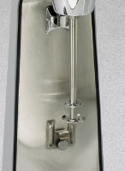 | Mixing Paddle  Code: 24-4132/11  Product Group: Mechanical Analysis Stirrer  Net Wt. 1 oz. (28 g).

Standards
ASTM D422, AASHTO T88

