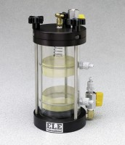 | Constant Head Sand/Gravel Permeameters  Code: 25-0562  Product Group: Constant Head Sand/Gravel Permeameters  3.0” (76 mm) i.d.

Standards
ASTM D2434

Further Information
Manometer Panel and Constant Head Tank System; not included, order separately.

Specification
Construction | Anodized aluminum end caps and clamping ring acrylic chamber.
Manometer Parts | Two. Located on the acrylic chambers side  wall. The distances between ports are equal to the diameter
Clamping Rods | Three; quick release type.
Weights | Net 7-12 lbs. (3.2-5.4 kg).

