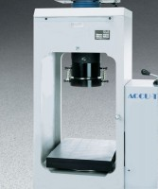 | Platen Set for 6" x 12" Concrete Cylinders  Code: 37-5500  Product Group: Rapid-Change Cylinder Platen Sets, Accu-Tek Touch 350 Series, Accu-Tek Touch 500 Series

Standards
ASTM C39, AASHTO T22

Further Information
Consists of upper platen assembly and spacer

