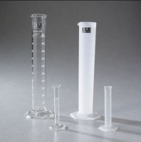 | Glass Graduated Cylinder - 500 ml Capacity  Code: 88-6010  Product Group: Glass Graduated Cylinders  500 ml capacity x 5 ml divisions.  Net Wt. 13 oz. (364 g).

Specification
Numbering | Double; with zero at top and bottom.
Packing | 1 cylinder/carton.

