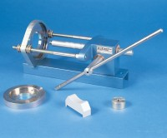 | Specimen Extruder Bench Mounting Frame for Extruding Specimens From Hoek Cells  Code: 70-2725  Product Group: Hoek Cells  Extrudes the specimen from its jacket without the need to drain the confining fluid. Incorporates a rack and pinion mechanism mounted in a steel body, with adjustable back plate. Supplied with NX extruder adaptor set.

