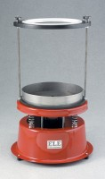 | Rice Test Vibrator  Code: 45-9315/01  Product Group: Rice Test Vibrator, Rice Test Vibrator  The Rice Test Vibrator is used with the 45-9300 6000 g Vacuum Pyknometer. Adjustable clamps hold the pyknometer securely to the base during vibration.

Standards
EN 12697-5, ASTM D2041, AASHTO T209

Further Information
For 220 – 240 V AC, 50 Hz, 1ph.

Specification
Dimensions | 495 x 30 mm (height x base diameter)
Motor | 1/20 hp, 1.6 amp
Weight | 5.5 kg
Motor | 1/20 h.p.; 3000 vpm; 1.6 amp.
Dimensions | 19-1/2â (495 mm) h.; 12 â (30 mm) base diameter.
Weight | Net 14.3 lbs. (6.5 kg).

