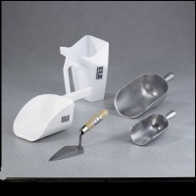 | Round Bottom Scoop 1 qt. Capacity  Code: 88-7302  Product Group: Round Bottom Scoops  1 qt. (0.946 liter) capacity. Aluminum.

Specification
Dimensions | 5â x 8â x 3â  (127 x 203 x 76 mm).

