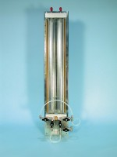 | Twin Burette Volume Change Unit.  Code: 26-1892  Product Group: Volume Change Measurement  Fitted with reversing valve and by-pass valve. The unit is fitted with burettes graduated 0 to 100 ml x 0.2 ml and is mounted on a solid panel for wall or bench mountingSupplied with 100 ml capacity x 0.2 ml burettes.

