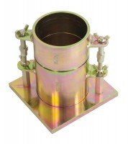 | Proctor Mould 1/30 Ft3.  Code: 24-9060  Product Group: Proctor compaction, Accessories for ASTM and Proctor compaction

Standards
ASTM D558, ASTM D559, ASTM D560, ASTM D698, ASTM D1557, AASHTO T99, AASHTO T134, AASHTO T135, AASHTO T136, AASHTO T180

Specification
Dimensions | 101.6 mm dia x 116.4 mm high
Rammer Mould Volume | 1/30 ft³
Construction | All steel, threaded studs with wing nuts, plated.
Weight | 5.4 kg

