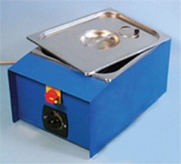 | Le Chatelier Water Bath  Code: 38-3420/01  Product Group: Soundness of Cement Paste by the Le Chatelier Method, Soundness  Manufactured from corrosion resistant material, complete with a removable rack to hold up to twelve moulds and timer unit.

Further Information
**NOT AVAILABLE FOR SALE IN THE USA**

