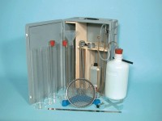 | Sand Equivalent Apparatus ASTM Aashto with Carrying Case.  Code: 24-4919  Product Group: Sand Equivalent Value, Sand Equivalent Value  Set Includes:  • 4 Plastic measuring cylinders  • 1 Carrying case  • 1 Weighted foot assembly  • 1 Irrigator tube  • 1 Rubber tubing complete with pinch clip  • 1 Funnel.

Standards
ASTM D2419, AASHTO T176

Further Information
**NOT AVAILABLE FOR SALE IN THE USA**

