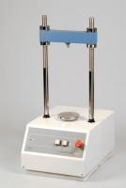 | Marshall Test 50  Code: 45-6810/01  Product Group: Load frames  • Geared screwjack and motor drive  • Precise speed  • Internal limit switch for both directions of travel  • Easy to use controls  This bench-mounting mechanical load frame is ruggedly constructed to encompass the strain and loads involved with the test. The unit is compact in size and can be quickly installed on a bench top, requiring only a power point. It has been designed for simple operation, is easy to clean and requires minimum maintenance.

Standards
EN 12697-34

Further Information
**NOT AVAILABLE FOR SALE IN THE USA**
Load frame, 50 kN capacity. Supplied without Breaking Head. For 220 - 240 V AC, 50 Hz, 1 ph.

