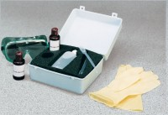 | ASR Detect  Code: 35-2170  Product Group: ASR Detect Alkali Silica Reaction (ASR) Kit

Specification
Components | One 60 ml bottle of yellow reagent, one 60 ml bottle of pink reagent, one 25 0 ml bottle of distilled water, two dispensing pipettes, protective gloves,  goggles, apron and carrying case.
Weight | Net 5 lbs. (2.3 kg).

