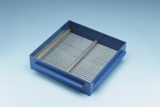 | Grid Sieve 5mm Slot Width for EN Aggregate Flakiness Test.  Code: 42-0306  Product Group: Grid Sieves  5mm

Standards
EN 933-3

Further Information
**NOT AVAILABLE FOR SALE IN THE USA**
Passing Size - 10 mm Retained Size - 8 mm

