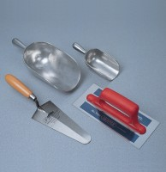 | Trowel - Gardeners type  Code: 81-0310  Product Group: Trowels and Floats

Further Information
**NOT AVAILABLE FOR SALE IN THE USA**

