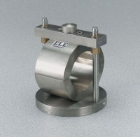 | 4" Marshall Breaking Head  Code: 45-6855  Product Group: Marshall Stability Breaking Head, Marshall Stability Tester

Standards
ASTM D6927, AASHTO T245

Specification
Design | Split-type.
Finish | Plated for easy cleaning and rust resistance.
Dimensions | 4â (101.6 mm) i.d.
Base | 6â (152 .4 mm) diam.
Weight | Net 17.3 lbs. (7.8 kg).

