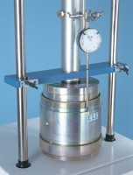 | Penetration Piston  Code: 24-9182  Product Group: Penetration and measurement  1.935 mm2 (3 in2) area foot of case hardened steel. Designed to fit all ELE load rings.

