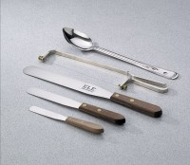 | Spatula - 6" Length  Code: 88-7510  Product Group: Spatulas  6” l. x 1” w. (152 x 25 mm) blade.

Specification
Handle | Wood.
Blade | Stainless steel.
Weight | Net 2 oz. (56 g).

