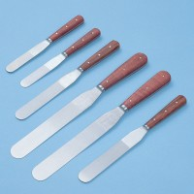 | Spatula 100 mm  Code: 81-0100  Product Group: Spatulas

Further Information
**NOT AVAILABLE FOR SALE IN THE USA**

