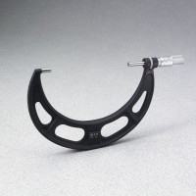 | Concrete Micrometer  Code: 34-5305  Product Group: Concrete Micrometer

Specification
Spindles | Copolymer plastic
Thimble and Sleeve | Satin chrome finish with black markings
Readability | 0.001"
Range | 5-1/2" to 6-1/2", 6" position at sleeves center.
Weight | Net 2 lbs (0.9 kg)

