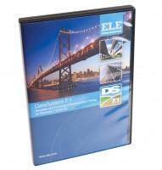 | DS7.1 One-Dimensional Consolidation Program for Windows 7, 32/64 bit  Code: 27-1772  Product Group: N/A  DS7.1 Consolidation Software provides all basic functions needed to record and analyse consolidation test data. Options are available for monitoring settlement on a log time or square-root time basis. Printouts and graphical plots are available for all stages including Mv and Cv moisture content, voids ratio plots, and initial sample conditions.

