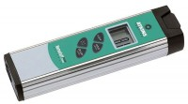 | Digital Thermometer  Code: 88-4420  Product Group: Digital Thermometers

Specification
Range | -100 to 999Â°F (-73 to 537Â°C)
Accuracy | Â±0.5Â°F (Â±0.3Â°C) over full range at ambient temperatures 68 to 86Â°F (20 to 30Â°C). NIST traceability certificate supplied.
Resolution | 0.1Â° or 1Â° (selectable).
Enclosure | Rugged ABS plastic construction; IPX7 waterproof rated
Power | 2x AAA 1.5V alkaline batteries
Display | LCD backlit display.
Dimensions | 6.5â x 2.1â x 1.25â (165 x 53 x 32 mm)
Weight | Net 5 oz. (142 g).

