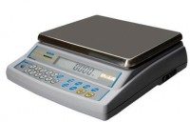 | Electronic Balance - 20 000 g x 0.1 g  Code: 78-5485/01  Product Group: Electronic Balances

Further Information
**Not available for sale in the USA**

Specification
Capacity resolution | 20000 g x 0.1 g
Pan size | 340 x 300 mm
Mains and battery | Yes
Dimensions (l x w x h) | 314 x 460 x 125 mm
Weight | 18 kg

