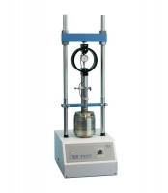 | CBR Test Accessory Set Metric  Code: 24-9177  Product Group: Versa-Loader  Includes lower platen, penetration piston assembly, dial indicator with 25 mm range 45 kN capacity proving ring and mounting hardware.

Standards
ASTM D1883, AASHTO T193

