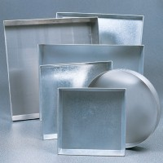 | Sample Tray - 910 x 910 x 76 mm  Code: 81-4160  Product Group: Sample Trays

Further Information
**NOT AVAILABLE FOR SALE IN THE USA**

