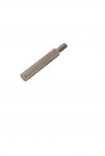 | Consistency Plunger  Code: 38-2010/10  Product Group: Vicat Method  Spare.

Standards
EN 196-3, EN 13454-2, ASTM C187, ASTM C191

Further Information
**NOT AVAILABLE FOR SALE IN THE USA**

