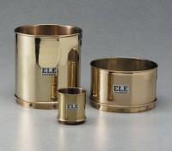 | Wet Washing Sieve - 8” diam. x 8-1/2” h. x 8” depth to mesh (203 x 216 x 203 mm). With No. 35 back-u  Code: 79-7030  Product Group: Wet Washing Sieves

Standards
ASTM E11

Specification
Frame | Brass
Mesh | Stainless steel.
Weight | Net 6 lbs. (2.7 kg)

