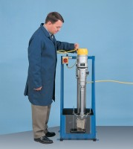 | Rock Core Drill Supplied with 2 X Nx Core Drill Bit  Code: 70-0095/01  Product Group: Sample Preparation  Cores may be cut from regular or irregular samples of rock or other material for end preparation prior to strength testing. Side guards and a drain tray provide protection against water spray and a sliding front allows access to the specimen clamp. The clamp provides maximum orientation for securing irregular block samples.

Further Information
Supplied complete with 2 x NX Core Barrel. For 220-240 V AC, 50 Hz, 1ph.

Specification
Dimensions (l x w x h) | 500 x 500 x 1160 mm
Drill Head Travel | 630 mm
Drill Speeds | 350 and 900 rpm
Weight | 80 kg

