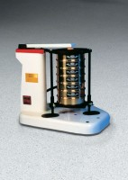 | Ro-Tap Sieve Shaker for 8" Diameter Sieves - 110V 60 Hz  Code: 80-0420/02  Product Group: Ro-Tap Sieve Shakers  110vAC, 60 Hz, 1ø.

Specification
Capacity | 6 full-height sieves, 8â (203 mm) diam., plus pan and cover.
Motor | 1/4 h.p.
Timer | Built-in; 30 minute digital timer.
Support Plate | Adjustable.
Dimensions | 28â w. x 21 â d. x 25 â h. (711 x 533 x 635 mm).
Weights | Net 165 lbs. (75 kg); Shpg. 185 lbs. (84 kg).

