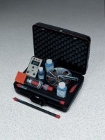 | Corrosion Mapping System  Code: 35-2165  Product Group: Corrosion Mapping System

Standards
ASTM C876

Specification
Half-Cell Type | Drive unit, electronic measuring device,  templates, measuring caps, gauge plates and carrying case.
Measurement Spacing | Net 18 lbs. (8.5 kg).
Memory Capacity | 15 ,866 half-cell readings; 12 8 max.  scans.
Power Supply | Battery powered. Charger 90/25 0vAC, 50/60Hz, 1Ã¸, AC (auto selectable).
Operating Temperature | 0 to 40Â°C.
Dimensions | 9.5â x 5.3â x 11 â (24 0 x 135 x 280 mm).
Weight | Net 14 lbs. (6.4 kg).

