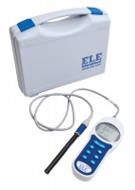 | Conductivity/Temp/Tds Meter with Electrode and Carrying Case  Code: 513-160  Product Group: Paqualab Test Meters

