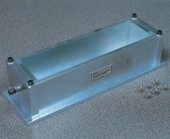 | Prism Mould 75 X 75 X 254mm  Code: 34-8538  Product Group: Prism Moulds and Inserts  For producing specimens 75mm square x 254mm gauge length to BS 812-123. The mould is made of steel and constructed so that the gauge length can be set within ± 2.54 mm limits. The overall length of the manufactured prism with steel inserts is 292mm.

Further Information
**NOT AVAILABLE FOR SALE IN THE USA**

