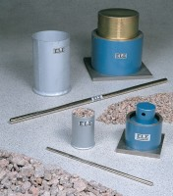 | 150mm Aggregate Crushing Value Apparatus. Supplied Complete with Metal Measure and Tamping Rod.  Code: 42-4300  Product Group: Aggregate Crushing Value (ACV) and Ten Percent Fines Value (TFV)  Comprising of 150 mm nominal diameter steel cylinder, plunger and base plate supplied complete with metal measure and tamping rod.

Standards
BS 812-112

Further Information
**NOT AVAILABLE FOR SALE IN THE USA**

