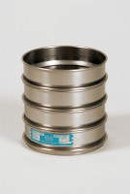 | 12in Dia ASTM Sieve 13.2mm Stainless Steel Mesh.  Code: 79-6240  Product Group: 12" Diameter ASTM Sieves, 12" Diameter ASTM Sieves, 12" Diameter ASTM Sieves

Standards
ASTM E11

Further Information
**NOT AVAILABLE FOR SALE IN THE USA**

