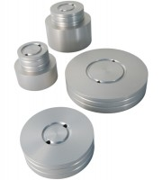 | 70mm Base Adaptor for 70mm Cells.  Code: 25-4176  Product Group: Base Pedestals, Specimen Base Adaptors  70mm Base Adaptor with Twin Pore Pressure Ports for 70mm Cells.

Standards
BS 1377, ASTM D2850, ASTM D4767, ASTM D7181, AASHTO T296, AASHTO T297

