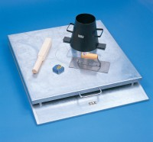 | Apparatus for Determining Flow In Concrete (Flow Table).  Code: 34-0450  Product Group: Flow Table  Comprising of mould, flow, tamper, metre rule, float and stopwatch

Further Information
**NOT AVAILABLE FOR SALE IN THE USA**

