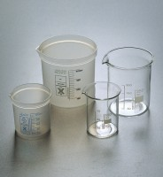 | Beaker - 600 ml  Code: 82-0200  Product Group: Beakers and Covers  Borosilicate glass, squat form.

Further Information
**NOT AVAILABLE FOR SALE IN THE USA**

