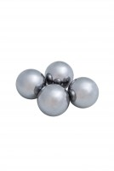 | Set of 12 Abrasive Charges EN)  Code: 42-5305/10  Product Group: Los Angeles Abrasion Machine  EN Set of 12.

Standards
EN 1097-2, ASTM C131, ASTM C535

Further Information
**NOT AVAILABLE FOR SALE IN THE USA**

