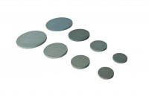 | Porous Stones 2.8"  Code: 25-6721  Product Group: Porous Stones, Tri-Flex 2 One-Cell Permeability Test System, Tri-Flex 2 Permeability Test Cell  2.8" diameter porous stones (pack of 2)

Standards
ASTM D2850, ASTM D4767, ASTM D5084, AASHTO T296, AASHTO T297, ASTM D7181

