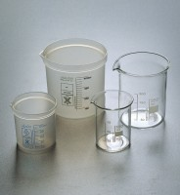 | Beaker - 100 ml  Code: 82-0120  Product Group: Beakers and Covers  Borosilicate glass, squat form.

Further Information
**NOT AVAILABLE FOR SALE IN THE USA**

