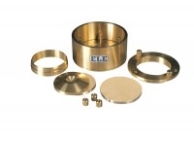 | Calibration Disc 75mm Cell  Code: 25-0509  Product Group: BS EN consolidation cells and accessories, Fixed Ring Consolidation

Standards
BS 1377, EN 1997-2

