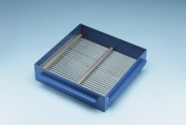 | Grid Sieve 4mm Slot Width for EN Aggregate Flakiness Test.  Code: 42-0304  Product Group: Grid Sieves  4mm

Standards
EN 933-3

Further Information
**NOT AVAILABLE FOR SALE IN THE USA**
Passing Size - 8 mm Retained Size - 6.3 mm

