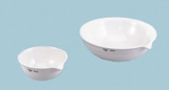 | Evaporating Dish - 1.285 ml Capacity  Code: 88-6718  Product Group: Evaporating Dishes  215 mm diam.; 1,285 ml capacity.

Specification
Construction | Porcelain; with lip.

