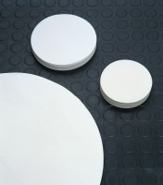 | Filter Paper - Slow  Code: 82-7931  Product Group: Filter Papers (Box of 100)  No. 95 x 110 mm diameter.

Further Information
**NOT AVAILABLE FOR SALE IN THE USA**

