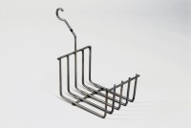 | Cradle  Code: 34-8105  Product Group: ELE Bouyancy Balance, Percentage Refusal Density (PRD), Hardened Concrete - Buoyancy Balance

Standards
EN 12697-32, EN 13280-4, BS 598-104

