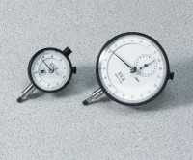 | Mechanical Dial Indicator - 1.0" Range Counter Clockwise Movement  Code: 88-4120  Product Group: Mechanical Dial Indicators, Pneumatic Consolidation Apparatus, Table Top Consolidation Apparatus

Specification
Range | 1.0"
Divisions | 0.001"
Movement | Counter-clockwise
Face Diameter | 2-1/4"
Contact Point | Immediate response, up or down; tip movement magnified to indicator hand with minimal friction; 3/16” (5 mm) radius x 1/4” (6 mm) l.
Dials | With continuous graduations and revolution counters.
Measure Movement | Measure movement away from dial case; pointer at zero with stem retracted.
Weight | Net 12 oz. (34 0 g).

