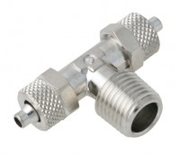 | 6mm T Connector.  Code: 26-1930  Product Group: Volume Change Measurement

