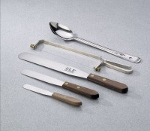 | Spatula - 4" Length  Code: 88-7500  Product Group: Spatulas  4” l. x 11/16” w. (102 x 19 mm) blade.

Specification
Handle | Wood.
Blade | Stainless steel.
Weight | Net 2 oz. (56 g).

