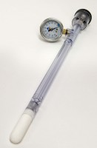 | Jet Fill Tensiometer 600 mm  Code: 514-038  Product Group: Tensiometers  600mm Long

Further Information
Requires Part No 514-034

