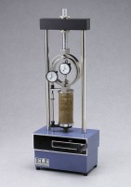 | Unconfined Compression Tester, Hand-Operated  Code: 25-3604  Product Group: Unconfined Compression Tester, Hand-Operated  1,500 lb. load capacity.

Standards
ASTM D2166, AASHTO T208

Specification
Specimen Height | Up to 8â (203 mm).
Platens | 3â (76 mm) diam.; with concentric grooves for  centering specimen.
Proving Ring | Plated steel; complete with dial indicator and calibration charts in English and Metric units.
Strain Indicator | English: 1.0â range x 0.001â graduations.  Metric: 25 mm range x 0.01 mm graduations.
Hand Crank | Two-piece; aluminum.
Base | One-piece; cast aluminum.
Crosshead | High-strength aluminum.
Dimensions | 10-5/8â w. x 6-3/8â d. x 26-1/4â h. (270 x  162 x 667 mm).
Weight | Net 43 lbs. (19.5 kg).; Shpg. 58 lbs. (26.3 kg).

